**Activity**

1. Learning how to edit OpenStreetMap
   1. Go to <https://www.openstreetmap.org/> and login.
   2. In the search bar, type “Hendersonville, NC.” Click the first result and then zoom in on the red dot by clicking the + sign on the right side of the map. Click the edit button on the top left of the page.
   3. On the right side of the map, click the Layers icon to change the satellite imagery we’ll be using as a reference point. The default is Bing aerial imagery. For this session we’ll use NC Latest Orthoimagery (NC OneMap).

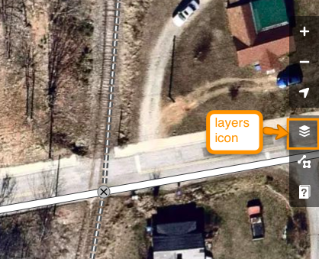

* 1. Some useful tips:
     1. To move the map around and zoom in and out, you can use the same gestures as Google Maps. To pan (move the map), click and drag the map. To zoom in, you can double click on the map, or click the + and - signs on the right.
     2. To undo a change you made, you can simply click the undo button.
     3. To save your changes, click Save. You’ll have a chance to add comments and also request that someone review your edits--essential for first-time editors!



* 1. Click on a feature. The feature editor opens on the left. You can see the different attributes (called tags in OSM). When you’re done, click the X to close the Edit feature window.

1. Create points

**

* 1. Pan and zoom your map around to find a parking lot.
  2. Click the Point tool at the top of the map (see image above) and click on the parking lot you found, close to the center of the lot (as best you can).
  3. The Edit Features window pops up on the left side of the page; search Parking Lot and click to select Parking Lot. You can see the point icon turns into a car icon.
  4. Right click on the point, and click the trashcan icon to delete. We’ll turn the parking lot into an area footprint instead.

1. Create Footprints for lots and buildings
   1. Click the Area tool at the top of the map.
   2. Using the Area Tool, click on a corner of the parking lot to start drawing your box. If you mess up, you can always use the Undo button to back up a step or two.
   3. Each time you click, you’ll draw a new *node*, which enables you to pivot your line and draw a geometric shape. Don’t worry if your corners aren’t perfectly square, we’ll take care of that in a moment!
   4. When you complete the shape and are back to the first node you drew, double click to finalize the shape. You can also click Enter to finish drawing your shape.
   5. **Right click** on the pulsing red line, and choose the Square icon to square your corners.

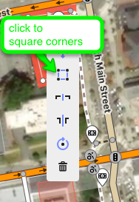

* 1. In the Edit Features box on the left side of the page, type “parking lot” in the search box, then select it from the menu. Notice there are a lot of fields you can fill out. If your lot is small enough to count the spaces, enter that number into Capacity.
  2. If your lot has Accessible parking spots, add a new tag by clicking the plus (+) symbol.

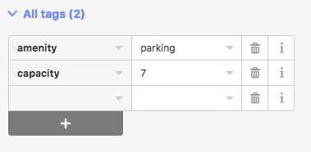

* 1. We’re going to add the tag “capacity:disabled” on the left side, with the number of accessible spaces as the value. In the parking lot below, there were 2 accessible spaces

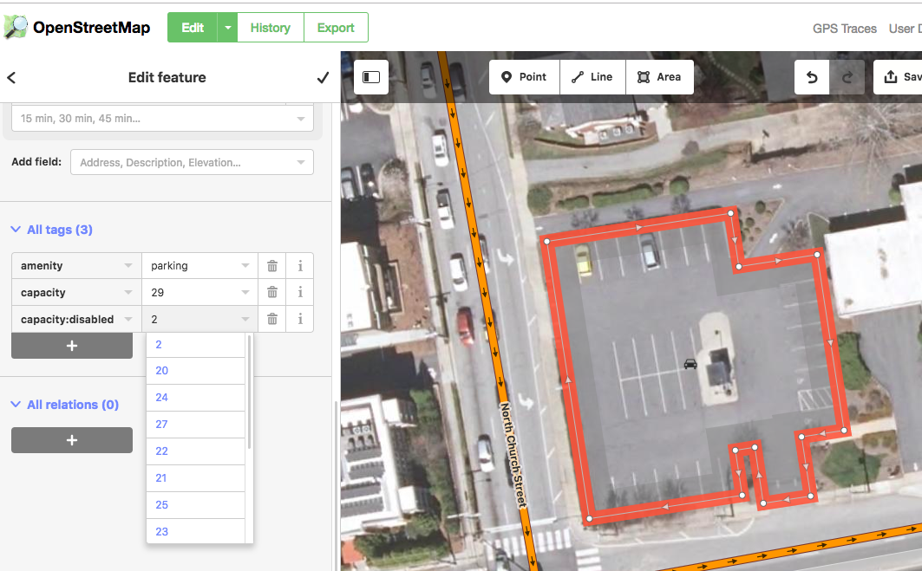

* 1. You can follow this same process to create footprint for buildings, such as businesses and houses, as well as parks, schools, basketball courts, etc. Each type of structure will have a different set of possible tags. *See the* [*OpenStreetMap Wiki*](https://wiki.openstreetmap.org/wiki/Map_Features) *for more information.*

1. Map Sidewalks
   1. Zoom in and pan around your map as necessary to find a sidewalk that you’d like to map.
   2. Click the Line tool at the top of the screen.
   3. Click on one end of the sidewalk to start drawing. Add nodes as necessary; for example if the sidewalk curves, you’ll want to create more nodes to create a curved line.
   4. Stop drawing when the sidewalk ends or reaches a street. When you’re done drawing your segment, double click or press Enter.
   5. Search for “sidewalk” and select it from the list of features. 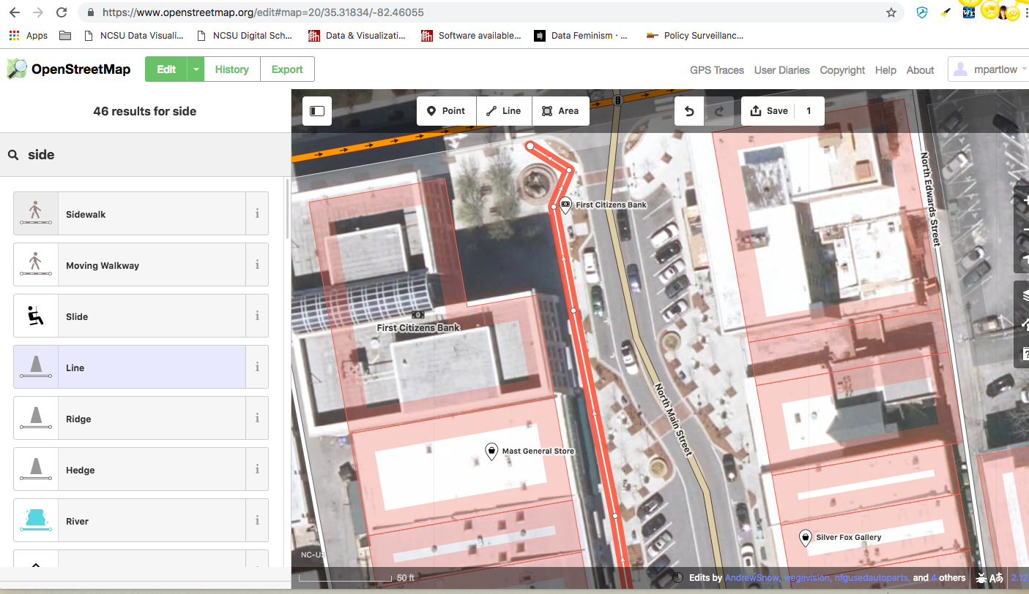
2. There are several things you can do to adjust your sidewalk if necessary. You can double click anywhere on the line to add a node, and then you can use that node to pull the sidewalk to move it as needed. In the middle of two nodes you’ll see an arrow--you can use that to adjust the line without creating a node.
3. If you need to split a line, double click to create a new node where you want to split the line, if there isn’t already a node there. Then, right click on the node and choose the split line tool (scissor icon). Do this at the end of your split as well. You can then edit or delete the new segment of line you created.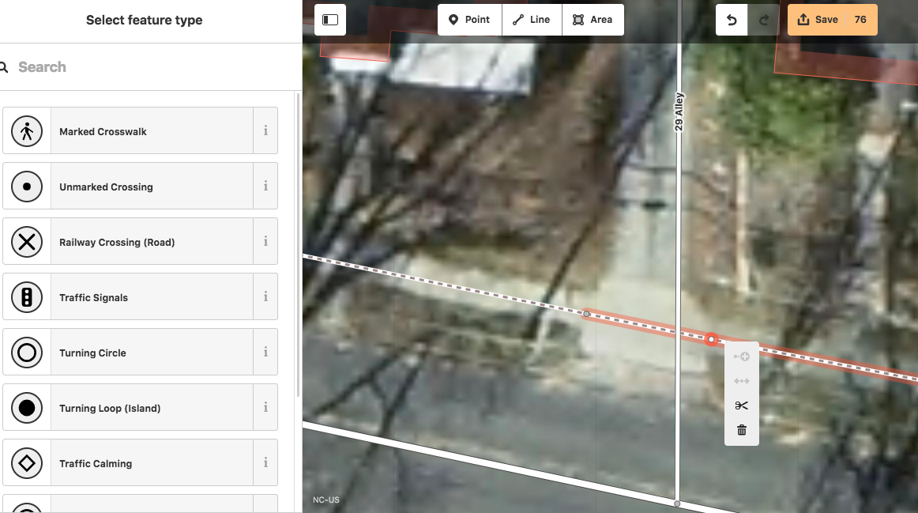
4. Next we want to tag our crosswalks. To indicate a Marked Crosswalk, draw a line across the street, **making sure to create nodes with the sidewalk, and where the crossing intersects with the street**. Search for and select “Marked Crosswalk” or “Unmarked Crossing,” depending on your crosswalk. 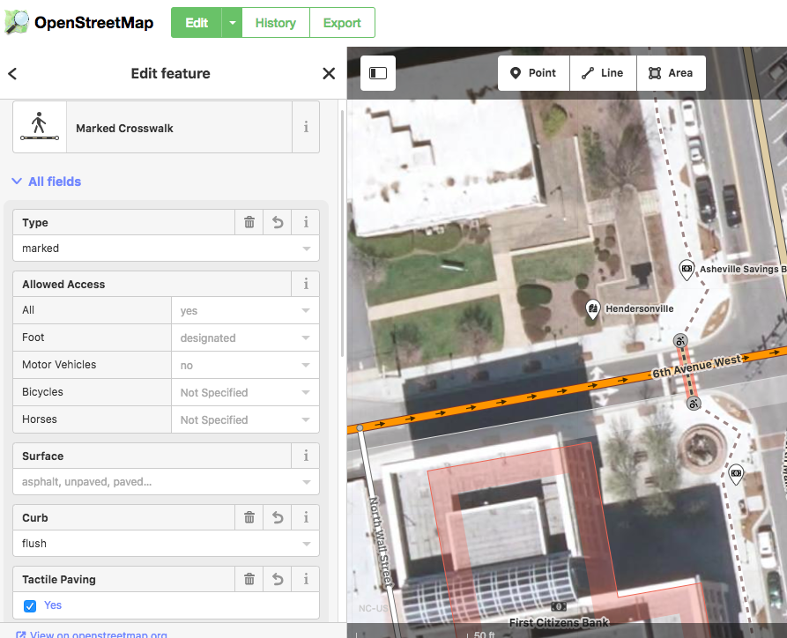
5. If you have a flush curb, click on the node where the sidewalk meets the street. Search for “flush curb” and select it from the list of features. If the crossing has [tactile paving](https://wiki.openstreetmap.org/wiki/Key:tactile_paving), click the word “unknown” so that it changes to “Yes.” 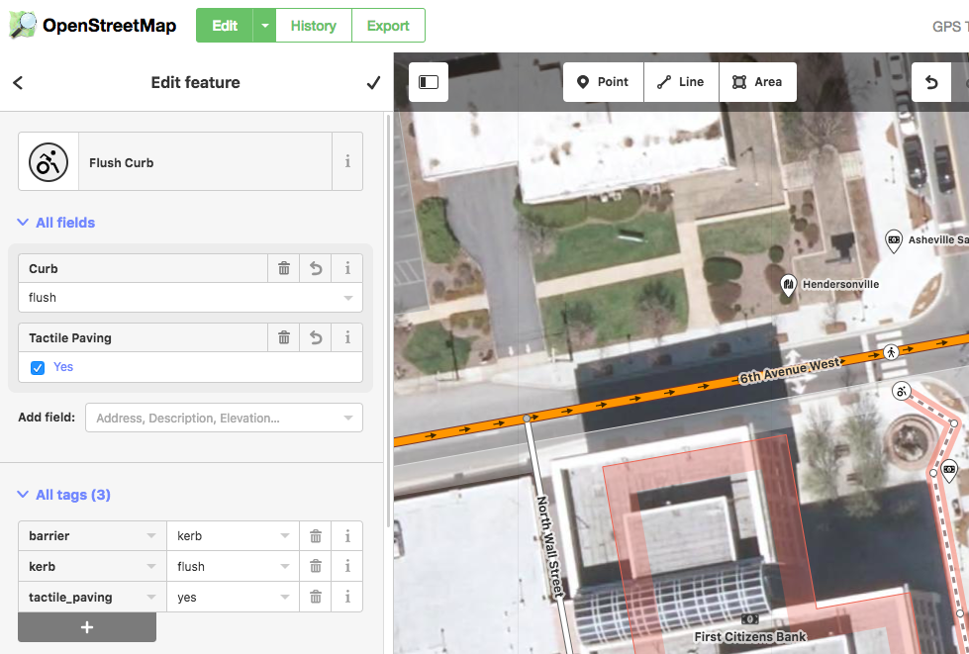

Part 2: Using Mapbox

1. Sign in: <https://www.mapbox.com/>
2. Click on the astronaut in the top right corner and choose Studio from the dropdown.
3. Click the New Style button. We’ll start with the Basic Template.
4. Type Raleigh into the search box and select the result that pops up. Zoom in to the map so you can see NC State’s campus.
5. On the left layer navigation pane, click Background at the very bottom of the list.
6. Click the palette to select a new background color.
7. Click on NC State University. Notice the popup has 2-3 layer elements, depending on where you click: pol-label, land use, and background. Click “land use.” Change the color of Parks, and then change the color of Schools.

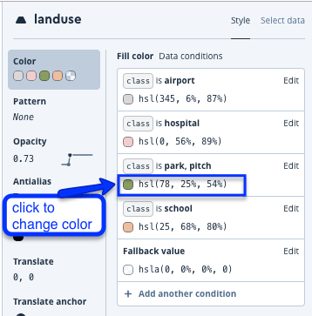

1. Click Publish at the top right, then choose Publish as new.

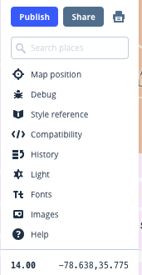

1. Click Share, toggle to make your map Public.

Part 3: Contribute to a mapping project!

* + Missing Maps: buildings in Chad, Moissala (7) <https://tasks.hotosm.org/project/5798?task=180>
  + Missing Maps: buildings in Chad, Moissala (5) <https://tasks.hotosm.org/project/5800?task=224>
  + NC Clear Path: <https://tasks.openstreetmap.us/project/92>